**Employee:**

Step 1: Click on Employee Link. Use your Windows credentials to log in:

Step 2: Please input your feedback in the “Employee Self – Assessment Section and “Employee Goals & Development Plan “Section”

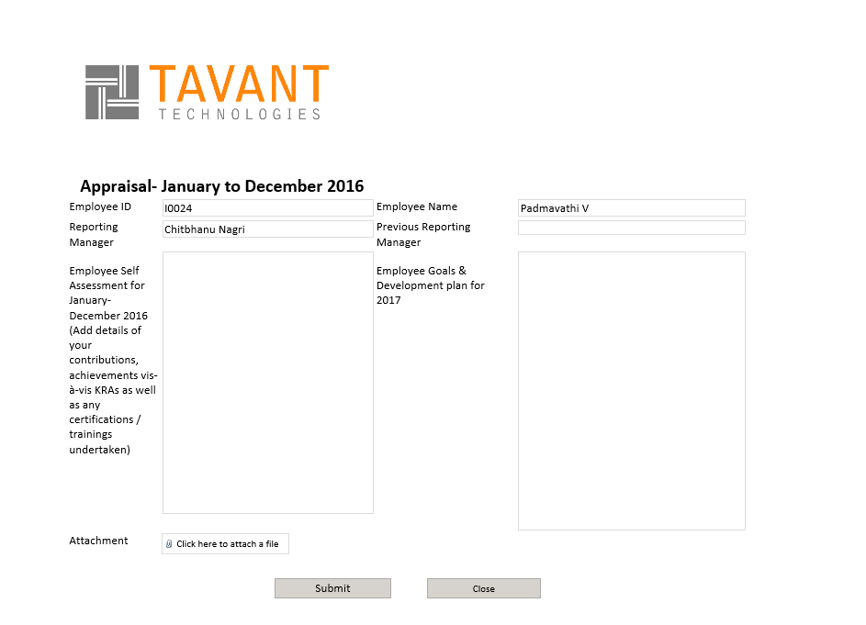

Step 3: As per the KRA attachment sheet, fill your KRAs save the document and upload in the Attachment

Step 4: Submit